Humanities Example_History of Art.pdf | Powered by Box

[yale.app.box.com/s/f8mwsuwk09ju30bs2laxuvvr0bxatla0](https://yale.app.box.com/s/f8mwsuwk09ju30bs2laxuvvr0bxatla0)

**HSAR 110**

**Label #1**

Museum label writing is a very specific sort of genre. Though short—often no more than 150 words—these labels are more difficult to craft than you might expect. The best ones have a strong topical sentence and do not merely describe the obvious or rehearse obscure genealogical facts about the maker or owner, but rather animate the meaning of the object and invite the viewer in to linger, look more closely at the object, and think about its purpose or life.

Writing about objects in compelling ways can be quite challenging. It asks us to look slowly and closely, to draw upon knowledge of materials and processes, and then to express a variety of multisensorial information in vivid prose. We will be developing those skills over the semester. To get started in the development of these skills and overcome your initial anxieties, we will first work on framing questions or lines of inquiry using ChatGPT. For this assignment, you will head to the Yale Art Gallery to look closely in person at one of the four ceramic objects listed below (I include photographs of them, their location and accession number, which you can locate on the object label). Drawing from lectures and readings, you should develop a series of 3-5 prompts for the AI program to write a 150-word text about the object. To ensure equity, everyone should use ChatGPT 4.0 (the premium version), accessed through Microsoft’s Bing search engine using the Edge browser. You ask Bing to go to creative mode, and it’s free.

For this assignment, spend time thinking about and articulating the parameters of your request. What kinds of prompts can you feed into the AI program to generate the kind of looking and writing described above? After feeding your prompt into ChatGPT, read over the response and write a short 150-word critique of the AI-generated label. What was successful? What is missing? Is there enough specificity or is it rather generic? Was there anything you observed in person that eluded the Chatbot’s notice? Your final submission will include a selfie of you next to the object you choose, your prompt, the Chatbot text, and your 150-word critique. You will be graded on the prompts you develop and your assessment of the AI-generated label. The Yale University Art Gallery is open during the following hours: Tuesday, Wednesday, and Friday 10 am-5 pm; Thursday 10 am-8 pm, Saturday and Sunday 11 am-5pm.

This assignment will help get you thinking in depth about ceramics, the topic of the first section. Please share a document, consisting of a selfie in front of your chosen object, your list of prompts, the text they generated, and your critical reflection, with your TF by 5 pm onWednesday, September 13. Your TF will be writing you shortly to identify themselves and provide instructions for submitting. This exercise is intended as a creative way to get you thinking about the material world and the language we use in communicating about objects.

Objects to choose from:

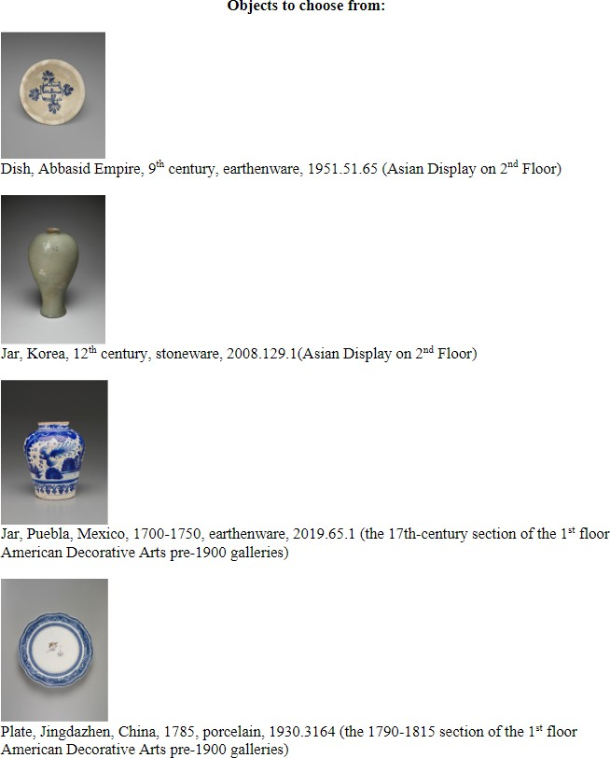

Dish, Abbasid Empire, 9th century, earthenware, 1951.51.65 (Asian Display on 2nd Floor)

Jar, Korea, 12th century, stoneware, 2008.129.1(Asian Display on 2nd Floor)

Jar, Puebla, Mexico, 1700-1750, earthenware, 2019.65.1 (the 17th-century section of the 1st

Floor, American Decorative Arts pre-1900 galleries)

Plate, Jingdazhen, China, 1785, porcelain, 1930.3164 (the 1790-1815 section of the 1st floor, American Decorative Arts pre-1900 galleries)